Confidential



Government Pensions Administration Agency
(GPAA)
:
SUPPLY AND INSTALLATION OF CANTEEN EQUIPMENT AT GPAA HEAD OFFICE

ALL BID DOCUMENTS TO BE DEPOSITED AT THE TENDER BOX SITUATED AT THE RECEPTION AREA AT:
34 HAMILTON STR
PRETORIA ARCADIA
PENSIONS ADMINISTRATION BUILDING

INDEX

Topic Page

- SBD Forms 04 of 78 to 35 of 78

- Special Conditions of Contract 36 of 78 to 38 of 78

- General Conditions of Contract 39 of 78 to 50 of 78

- Terms of Reference Annexure A and B 51 of 78 to 77 of 78

- Evaluation criteria 78 of 78 to 78 of 78

Index to Administrative Annexure

Annexure Topic

A SBD Forms

B Special Conditions of Contract

C General Conditions of Contract

SBD1

INVITATION TO BID

YOU ARE HEREBY INVITED TO BID FOR REQUIREMENTS OF GOVERNMENT PENSIONS ADMINISTRATION AGENCY (GPAA)

BID NUMBER: GPAA 13/2017 CLOSING DATE: 13 March 2017
CLOSING TIME: 11:00am
DESCRIPTION Supply and Install Canteen Equipment

THE SUCCESSFUL BIDDER WILL BE REQUIRED TO FILL IN AND SIGN A WRITTEN CONTRACT FORM (SBD7.1 / SBD7.2 / SBD7.3)

BID DOCUMENTS MAY BE POSTED TO OR DEPOSITED IN THE BID BOX SITUATED AT GEPF ADDRESSED TO:
The CEO: Government Pensions Administration Agency (GPAA)
Bid Administration
34 HAMILTON STR
ARCADIA
PRETORIA, TSHWANE
0001
Bidders should ensure that bids are delivered timorously to the correct address. If the bid is late, it will not be accepted for consideration. The bid box is generally open 8 hours a day between 08:00 to 16:30, Monday to Fridays.

ALL BIDS MUST BE SUBMITTED WITH THE STANDARD FORMS – (NOT TO BE RE-TYPED)
THIS BID IS SUBJECT TO THE GENERAL CONDITIONS OF CONTRACT (GCC) AND, IF APPLICABLE, ANY OTHER SPECIAL CONDITIONS OF CONTRACT

THE FOLLOWING PARTICULARS MUST BE FURNISHED (FAILURE TO DO SO MAY RESULT IN THE BID BEING DISQUALIFIED) ALL STANADARD BIDDING DOCUMENT AS ATTACHED

NAME OF BIDDER……………………………………………………………………………………………………………

POSTAL ADDRESS………………………………………………………………………………………………………….

STREET ADDRESS…………………………………………………………………………………………………………

TELEPHONE NUMBER CODE……………NUMBER……………………………………………….

CELLPHONE NUMBER …………………………………

FACSIMILE NUMBER CODE ………… NUMBER…………………………………

VAT REGISTRATION NUMBER …………………………………………………………………………

HAS A TAX CLEARANCE CERTIFICATE BEEN SUBMITTED (SBD2)? YES/NO

SIGNATURE OF BIDDER ……………………………………………………

DATE ……………………………………………………

CAPACITY UNDER WHICH THIS BID IS SIGNED ……………………………………………

SBD 4

DECLARATION OF INTEREST

1. Any legal person, including persons employed by the state¹, or persons having a kinship with persons employed by the state, including a blood relationship, may make an offer or offers in terms of this invitation to bid (includes a price quotation, advertised competitive bid, limited bid or proposal). In view of possible allegations of favouritism, should the resulting bid, or part thereof, be awarded to persons employed by the state, or to persons connected with or related to them, it is required that the bidder or his/her authorised representative declare his/her position in relation to the evaluating/adjudicating authority where-

- the bidder is employed by the state; and/or

- the legal person on whose behalf the bidding document is signed, has a relationship with persons/a person who are/is involved in the evaluation and or adjudication of the bid(s), or where it is known that such a relationship exists between the person or persons for or on whose behalf the declarant acts and persons who are involved with the evaluation and or adjudication of the bid.

2. In order to give effect to the above, the following questionnaire must be completed and submitted with the bid.

2.1 Full Name of bidder or his or her representative: ……………………………………………

  - Identity Number: …………………………………………………………………………………

  - Position occupied in the Company (director, trustee, shareholder²): ………………………

  - Company Registration Number: ………………………………………………………………

  - Tax Reference Number: ………………………………………………………………………

  - VAT Registration Number: ………………………………………………………………………
2.6.1 The names of all directors / trustees / shareholders / members, their individual identity numbers, tax reference numbers and, if applicable, employee / persal numbers must be indicated in paragraph 3 below.
¹“State” means –
(a) any national or provincial department, national or provincial public entity or constitutional institution within the meaning of the Public Finance Management Act, 1999 (Act No. 1 of 1999);
(b) any municipality or municipal entity;
(c) provincial legislature;
(d) national Assembly or the national Council of provinces; or
(e) Parliament.

²”Shareholder” means a person who owns shares in the company and is actively involved in the management of the enterprise or business and exercises control over the enterprise.

2.7 Are you or any person connected with the bidder YES / NO
presently employed by the state?

    - If so, furnish the following particulars:

Name of person / director / trustee / shareholder/ member: ……....………………………
Name of state institution at which you or the person
connected to the bidder is employed : ………………………………
Position occupied in the state institution: ………………………………

Any other particulars:
………………………………………………………………

………………………………………………………………
………………………………………………………………

    - If you are presently employed by the state, did you obtain YES / NO
the appropriate authority to undertake remunerative
work outside employment in the public sector?

      - If yes, did you attached proof of such authority to the bid YES / NO
document?

(Note: Failure to submit proof of such authority, where
applicable, may result in the disqualification of the bid.

      - If no, furnish reasons for non-submission of such proof:

…………………………………………………………………….
…………………………………………………………………….
…………………………………………………………………….

  - Did you or your spouse, or any of the company’s directors / YES / NO
trustees / shareholders / members or their spouses conduct
business with the state in the previous twelve months?

    - If so, furnish particulars:
…………………………………………………………………..
…………………………………………………………………..
…………………………………………………………………...

  - Do you, or any person connected with the bidder, have YES / NO
any relationship (family, friend, other) with a person
employed by the state and who may be involved with
the evaluation and or adjudication of this bid?
2.9.1If so, furnish particulars.
……………………………………………………………...
…………………………………………………………..….
………………………………………………………………

2.10 Are you, or any person connected with the bidder, YES/NO
aware of any relationship (family, friend, other) between
any other bidder and any person employed by the state
who may be involved with the evaluation and or adjudication
of this bid?

2.10.1 If so, furnish particulars.
………………………………………………………………
………………………………………………………………
………………………………………………………………

2.11 Do you or any of the directors / trustees / shareholders / members YES/NO
of the company have any interest in any other related companies
whether or not they are bidding for this contract?

2.11.1 If so, furnish particulars:
…………………………………………………………………………….
…………………………………………………………………………….
…………………………………………………………………………….

Full details of directors / trustees / members / shareholders.

Full Name | Identity Number | Personal Tax Reference Number | State Employee Number / Persal Number

4 DECLARATION

I, THE UNDERSIGNED (NAME)…………………………………………………………………

CERTIFY THAT THE INFORMATION FURNISHED IN PARAGRAPHS 2 and 3 ABOVE IS CORRECT.
I ACCEPT THAT THE STATE MAY REJECT THE BID OR ACT AGAINST ME IN TERMS OF PARAGRAPH 23 OF THE GENERAL CONDITIONS OF CONTRACT SHOULD THIS DECLARATION PROVE TO BE FALSE.

………………………………….. ..……………………………………………
Signature Date

…………………………………. ………………………………………………
Position Name of bidder

SBD 6.1

PREFERENCE POINTS CLAIM FORM IN TERMS OF THE PREFERENTIAL PROCUREMENT REGULATIONS 2011

This preference form must form part of all bids invited. It contains general information and serves as a claim form for preference points for Broad-Based Black Economic Empowerment (B-BBEE) Status Level of Contribution

NB: BEFORE COMPLETING THIS FORM, BIDDERS MUST STUDY THE GENERAL CONDITIONS, DEFINITIONS AND DIRECTIVES APPLICABLE IN RESPECT OF B-BBEE, AS PRESCRIBED IN THE PREFERENTIAL PROCUREMENT REGULATIONS, 2011.

- GENERAL CONDITIONS

  - The following preference point systems are applicable to all bids:

- the 80/20 system for requirements with a Rand value of up to R1 000 000 (all applicable taxes included); and
- the 90/10 system for requirements with a Rand value above R1 000 000 (all applicable taxes included).

  - The value of this bid is estimated to exceed R1 000 000 (all applicable taxes included) and therefore the 90/10 system shall be applicable.

  - Preference points for this bid shall be awarded for:

- Price; and
- B-BBEE Status Level of Contribution.

1.3.1 The maximum points for this bid are allocated as follows:

POINTS

1.3.1.1 PRICE 90.

1.3.1.2 B-BBEE STATUS LEVEL OF CONTRIBUTION 10.

Total points for Price and B-BBEE must not exceed 100

1.4 Failure on the part of a bidder to fill in and/or to sign this form and submit a B-BBEE Verification Certificate from a Verification Agency accredited by the South African Accreditation System (SANAS) or a Registered Auditor approved by the Independent Regulatory Board of Auditors (IRBA) or an Accounting Officer as contemplated in the Close Corporation Act (CCA) together with the bid, will be interpreted to mean that preference points for B-BBEE status level of contribution are not claimed.

1.5. The purchaser reserves the right to require of a bidder, either before a bid is adjudicated or at any time subsequently, to substantiate any claim in regard to preferences, in any manner required by the purchaser.

2. DEFINITIONS

2..1 “all applicable taxes” includes value-added tax, pay as you earn, income tax, unemployment insurance fund contributions and skills development levies;

2.2 “B-BBEE” means broad-based black economic empowerment as defined in section 1 of the Broad -Based Black Economic Empowerment Act;

2.3 “B-BBEE status level of contributor” means the B-BBEE status received by a measured entity based on its overall performance using the relevant scorecard contained in the Codes of Good Practice on Black Economic Empowerment, issued in terms of section 9(1) of the Broad-Based Black Economic Empowerment Act;

2.4 “bid” means a written offer in a prescribed or stipulated form in response to an invitation by an organ of state for the provision of services, works or goods, through price quotations, advertised competitive bidding processes or proposals;

2.5 “Broad-Based Black Economic Empowerment Act” means the Broad-Based Black Economic Empowerment Act, 2003 (Act No. 53 of 2003);

2.6 “comparative price” means the price after the factors of a non-firm price and all unconditional discounts that can be utilized have been taken into consideration;

2.7 “consortium or joint venture” means an association of persons for the purpose of combining their expertise, property, capital, efforts, skill and knowledge in an activity for the execution of a contract;

2.8 “contract” means the agreement that results from the acceptance of a bid by an organ of state;

2.9 “EME” means any enterprise with an annual total revenue of R5 million or less .

2.10 “Firm price” means the price that is only subject to adjustments in accordance with the actual increase or decrease resulting from the change, imposition, or abolition of customs or excise duty and any other duty, levy, or tax, which, in terms of the law or regulation, is binding on the contractor and demonstrably has an influence on the price of any supplies, or the rendering costs of any service, for the execution of the contract;

2.11 “functionality” means the measurement according to predetermined norms, as set out in the bid documents, of a service or commodity that is designed to be practical and useful, working or operating, taking into account, among other factors, the quality, reliability, viability and durability of a service and the technical capacity and ability of a bidder;

2.12 “non-firm prices” means all prices other than “firm” prices;

2.13 “person” includes a juristic person;

2.14 “rand value” means the total estimated value of a contract in South African currency, calculated at
the time of bid invitations, and includes all applicable taxes and excise duties;

2.15 “sub-contract” means the primary contractor’s assigning, leasing, making out work to, or employing, another person to support such primary contractor in the execution of part of a project in terms of the contract;

2.16 “total revenue” bears the same meaning assigned to this expression in the Codes of Good Practice on Black Economic Empowerment, issued in terms of section 9(1) of the Broad- Based Black Economic Empowerment Act and promulgated in the Government Gazette on 9 February 2007;

2.17 “trust” means the arrangement through which the property of one person is made over or bequeathed to a trustee to administer such property for the benefit of another person; and

2.18 “trustee” means any person, including the founder of a trust, to whom property is bequeathed in order for such property to be administered for the benefit of another person.

3. ADJUDICATION USING A POINT SYSTEM

3.1 The bidder obtaining the highest number of total points will be awarded the contract.

3.2 Preference points shall be calculated after prices have been brought to a comparative basis taking into account all factors of non-firm prices and all unconditional discounts;.
3.3 Points scored must be rounded off to the nearest 2 decimal places.

3.4 In the event that two or more bids have scored equal total points, the successful bid
must be the one scoring the highest number of preference points for B-BBEE.

3.5 However, when functionality is part of the evaluation process and two or more bids have
scored equal points including equal preference points for B-BBEE, the successful bid must be the one scoring the highest score for functionality.
3.6 Should two or more bids be equal in all respects, the award shall be decided by the
drawing of lots.

4. POINTS AWARDED FOR PRICE

4.1 THE 90/10 PREFERENCE POINT SYSTEMS

A maximum of 90 points is allocated for price on the following basis:

90/10

$\text{Ps}=\text{90}\left(1−\frac{\text{Pt}−P\text{min}}{P\text{min}}\right)$
Where

Ps = Points scored for comparative price of bid under consideration

Pt = Comparative price of bid under consideration

Pmin = Comparative price of lowest acceptable bid

- Points awarded for B-BBEE Status Level of Contribution

5.1 In terms of Regulation 5 (2) and 6 (2) of the Preferential Procurement Regulations, preference points must be awarded to a bidder for attaining the B-BBEE status level of contribution in accordance with the table below:

B-BBEE Status Level of Contributor | Number of points  (90/10 system) | Number of points  (80/20 system)
1 | 10 | 20
2 | 9 | 18
3 | 8 | 16
4 | 5 | 12
5 | 4 | 8
6 | 3 | 6
7 | 2 | 4
8 | 1 | 2
Non-compliant contributor | 0 | 0

5.2 Bidders who qualify as EMEs in terms of the B-BBEE Act must submit a certificate issued by an Accounting Officer as contemplated in the CCA or a Verification Agency accredited by SANAS or a Registered Auditor. Registered auditors do not need to meet the prerequisite for IRBA’s approval for the purpose of conducting verification and issuing EMEs with B-BBEE Status Level Certificates.

5.3 Bidders other than EMEs must submit their original and valid B-BBEE status level verification certificate or a certified copy thereof, substantiating their B-BBEE rating issued by a Registered Auditor approved by IRBA or a Verification Agency accredited by SANAS.

5.4 A trust, consortium or joint venture, will qualify for points for their B-BBEE status level as a legal entity, provided that the entity submits their B-BBEE status level certificate.

5.5 A trust, consortium or joint venture will qualify for points for their B-BBEE status level as an unincorporated entity, provided that the entity submits their consolidated B-BBEE scorecard as if they were a group structure and that such a consolidated B-BBEE scorecard is prepared for every separate bid.

5.6 Tertiary institutions and public entities will be required to submit their B-BBEE status level certificates in terms of the specialized scorecard contained in the B-BBEE Codes of Good Practice.

5.7 A person will not be awarded points for B-BBEE status level if it is indicated in the bid documents that such a bidder intends sub-contracting more than 25% of the value of the contract to any other enterprise that does not qualify for at least the points that such a bidder qualifies for, unless the intended sub-contractor is an EME that has the capability and ability to execute the sub-contract.

5.8 A person awarded a contract may not sub-contract more than 25% of the value of the contract to any other enterprise that does not have an equal or higher B-BBEE status level than the person concerned, unless the contract is sub-contracted to an EME that has the capability and ability to execute the sub-contract.

6. BID DECLARATION

6.1 Bidders who claim points in respect of B-BBEE Status Level of Contribution must complete the following:

7. B-BBEE STATUS LEVEL OF CONTRIBUTION CLAIMED IN TERMS OF PARAGRAPHS 1.3.1.2 AND 5.1

7.1 B-BBEE Status Level of Contribution: …………. = ………… (maximum of 10 points)

(Points claimed in respect of paragraph 7.1 must be in accordance with the table reflected in paragraph 5.1 and must be substantiated by means of a B-BBEE certificate issued by a Verification Agency accredited by SANAS or a Registered Auditor approved by IRBA or an Accounting Officer as contemplated in the CCA).

8 SUB-CONTRACTING

8.1 Will any portion of the contract be sub-contracted? YES / NO (delete which is not applicable)
8.1.1 If yes, indicate:
(i) what percentage of the contract will be subcontracted? ............……%
(ii) the name of the sub-contractor? …………………………………………
(iii) the B-BBEE status level of the sub-contractor? ………
(iv) whether the sub-contractor is an EME? YES/NO (delete which is not applicable)

9 DECLARATION WITH REGARD TO COMPANY/FIRM

9.1 Name of company/firm :

9.2 VAT registration number :

9.3 Company registration number ……………………………………………………………………. :
9.4 TYPE OF COMPANY/ FIRM

Partnership/Joint Venture / Consortium
One person business/sole propriety
Close corporation
Company
(Pty) Limited
[Tick applicable box]

9.5 DESCRIBE PRINCIPAL BUSINESS ACTIVITIES

…………..
………………
……………..

9.6 COMPANY CLASSIFICATION

Manufacturer
Supplier
Professional service provider
Other service providers, e.g. transporter, etc.
[Tick applicable box]

9.7 Total number of years the company/firm has been in business? …………………………

9.8 I/we, the undersigned, who is / are duly authorised to do so on behalf of the company/firm, certify that the points claimed, based on the B-BBE status level of contribution indicated in paragraph 7 of the foregoing certificate, qualifies the company/ firm for the preference(s) shown and I / we acknowledge that:

(i) The information furnished is true and correct;

(ii) The preference points claimed are in accordance with the General Conditions as indicated in paragraph 1 of this form.

(iii) In the event of a contract being awarded as a result of points claimed as shown in paragraph 7, the contractor may be required to furnish documentary proof to the satisfaction of the purchaser that the claims are correct;

(iv) If the B-BBEE status level of contribution has been claimed or obtained on a fraudulent basis or any of the conditions of contract have not been fulfilled, the purchaser may, in addition to any other remedy it may have –

(a) disqualify the person from the bidding process;

(b) recover costs, losses or damages it has incurred or suffered as a result of that person’s conduct;

(c) cancel the contract and claim any damages which it has suffered as a result of having to make less favourable arrangements due to such cancellation;

- restrict the bidder or contractor, its shareholders and directors, or only the shareholders and directors who acted on a fraudulent basis, from obtaining business from any organ of state for a period not exceeding 10 years, after the audi alteram partem (hear the other side) rule has been applied; and

- forward the matter for criminal prosecution

WITNESSES:
- ………………………………………

……………………………………
SIGNATURE(S) OF BIDDER(S)

- ………………………………………
DATE:………………………………..
ADDRESS:…………………………..

SBD8

DECLARATION OF BIDDER’S PAST SUPPLY CHAIN MANAGEMENT PRACTICES

- This Standard Bidding Document must form part of all bids invited.

- It serves as a declaration to be used by institutions in ensuring that when goods and services are being procured, all reasonable steps are taken to combat the abuse of the supply chain management system.

- The bid of any bidder may be disregarded if that bidder, or any of its directors have:
- abused the institution’s supply chain management system;
- committed fraud or any other improper conduct in relation to such system; or
- Failed to perform on any previous contract.

- In order to give effect to the above, the following questionnaire must be completed and submitted with the bid.

Item | Question | Yes | No
4.1 | Is the bidder or any of its directors listed on the National Treasury’s database as companies or persons prohibited from doing business with the public sector?  (Companies or persons who are listed on this database were informed in writing of this restriction by the National Treasury after the audi alteram partem rule was applied). | Yes | No
4.1.1 | If so, furnish particulars:
4.2 | Is the bidder or any of its directors listed on the Register for Tender Defaulters in terms of section 29 of the Prevention and Combating of Corrupt Activities Act (No 12 of 2004)?  To access this Register enter the National Treasury’s website, www.treasury.gov.za, click on the icon “Register for Tender Defaulters” or submit your written request for a hard copy of the Register to facsimile number (012) 3265445. | Yes | No
4.2.1 | If so, furnish particulars:
4.3 | Was the bidder or any of its directors convicted by a court of law (including a court outside of the Republic of South Africa) for fraud or corruption during the past five years? | Yes | No
4.3.1 | If so, furnish particulars:
4.4 | Was any contract between the bidder and any organ of state terminated during the past five years on account of failure to perform on or comply with the contract? | Yes | No
4.4.1 | If so, furnish particulars:

CERTIFICATION

I, THE UNDERSIGNED (FULL NAME)………………………… CERTIFY THAT THE INFORMATION FURNISHED ON THIS DECLARATION FORM IS TRUE AND CORRECT.

I ACCEPT THAT, IN ADDITION TO CANCELLATION OF A CONTRACT, ACTION MAY BE TAKEN AGAINST ME SHOULD THIS DECLARATION PROVE TO BE FALSE.

………………………………………... …………………………………..
Signature Date

………………………………………... …………………………………..
Position Name of Bidder

SBD 9

CERTIFICATE OF INDEPENDENT BID DETERMINATION

1 This Standard Bidding Document (SBD) must form part of all bids¹ invited.
2 Section 4 (1) (b) (iii) of the Competition Act No. 89 of 1998, as amended, prohibits an agreement between, or concerted practice by, firms, or a decision by an association of firms, if it is between parties in a horizontal relationship and if it involves collusive bidding (or bid rigging).² Collusive bidding is a pe se prohibition meaning that it cannot be justified under any grounds.
3 Treasury Regulation 16A9 prescribes that accounting officers and accounting authorities must take all reasonable steps to prevent abuse of the supply chain management system and authorizes accounting officers and accounting authorities to:

a. disregard the bid of any bidder if that bidder, or any of its directors have abused the institution’s supply chain management system and or committed fraud or any other improper conduct in relation to such system.

b. cancel a contract awarded to a supplier of goods and services if the supplier committed any corrupt or fraudulent act during the bidding process or the execution of that contract.

- This SBD serves as a certificate of declaration that would be used by institutions to ensure that, when bids are considered, reasonable steps are taken to prevent any form of bid-rigging.
- In order to give effect to the above, the attached Certificate of Bid Determination (SBD 9) must be completed and submitted with the bid:

¹ Includes price quotations, advertised competitive bids, limited bids and proposals.

² Bid rigging (or collusive bidding) occurs when businesses, that would otherwise be expected to compete, secretly conspire to raise prices or lower the quality of goods and / or services for purchasers who wish to acquire goods and / or services through a bidding process. Bid rigging is, therefore, an agreement between competitors not to compete.

SBD 9

CERTIFICATE OF INDEPENDENT BID DETERMINATION

I, the undersigned, in submitting the accompanying bid:
________________________________________________________________________
(Bid Number and Description)

in response to the invitation for the bid made by:
________________________________________________________________________
(Name of Institution)

do hereby make the following statements that I certify to be true and complete in every respect:

I certify, on behalf of:_______________________________________________________that:
(Name of Bidder)
- I have read and I understand the contents of this Certificate;
- I understand that the accompanying bid will be disqualified if this Certificate is found not to be true and complete in every respect;
- I am authorized by the bidder to sign this Certificate, and to submit the accompanying bid, on behalf of the bidder;
- Each person whose signature appears on the accompanying bid has been authorized by the bidder to determine the terms of, and to sign the bid, on behalf of the bidder;

- For the purposes of this Certificate and the accompanying bid, I understand that the word “competitor” shall include any individual or organization, other than the bidder, whether or not affiliated with the bidder, who:

(a) has been requested to submit a bid in response to this bid invitation;
(b) could potentially submit a bid in response to this bid invitation, based on their qualifications, abilities or experience; and
(c) provides the same goods and services as the bidder and/or is in the same line of business as the bidder

- The bidder has arrived at the accompanying bid independently from, and without consultation, communication, agreement or arrangement with any competitor. However communication between partners in a joint venture or consortium³ will not be construed as collusive bidding.
- In particular, without limiting the generality of paragraphs 6 above, there has been no consultation, communication, agreement or arrangement with any competitor regarding:
- prices;
- geographical area where product or service will be rendered (market allocation)
(c) methods, factors or formulas used to calculate prices;
(d) the intention or decision to submit or not to submit, a bid;
(e) the submission of a bid which does not meet the specifications and conditions of the bid; or
(f) bidding with the intention not to win the bid.
- In addition, there have been no consultations, communications, agreements or arrangements with any competitor regarding the quality, quantity, specifications and conditions or delivery particulars of the products or services to which this bid invitation relates.

- The terms of the accompanying bid have not been, and will not be, disclosed by the bidder, directly or indirectly, to any competitor, prior to the date and time of the official bid opening or of the awarding of the contract.

- I am aware that, in addition and without prejudice to any other remedy provided to combat any restrictive practices related to bids and contracts, bids that are suspicious will be reported to the Competition Commission for investigation and

possible imposition of administrative penalties in terms of section 59 of the Competition Act No 89 of 1998 and or may be reported to the National Prosecuting Authority (NPA) for criminal investigation and or may be restricted from conducting business with the public sector for a period not exceeding ten (10) years in terms of the Prevention and Combating of Corrupt Activities Act No 12 of 2004 or any other applicable legislation.

………………………………………………… ……………………
Signature Date
…………………………………………………. ………………………
Position Name of Bidder

Annexure A

(GPAA)

SCM
Special Conditions of Contract

Special Condition of Contract

General Notes

The purpose of this Special Conditions of Contract (SCC) is to:

- Draw special attention to certain special conditions applicable to Bids, Contracts, Agreements and Orders of the Government Pensions Administration Agency (GPAA); and

(ii) To ensure that all bidders are familiar with the special provisions, requirements and conditions that will be applicable in the undertaking of the project and which will form part of the contract documentation and of which due cognisance must be taken in the bidding process.

In this document words in the singular also mean in the plural and vice versa and words in the masculine also mean in the feminine and neuter.

The General Conditions of Contract (GCC) also forms part of all bidding documents and must be read in conjunction with this Special Conditions of Contract.

Whenever there is a conflict between the GCC and the SCC, the provisions in the SCC shall prevail.

  - Bid Submission

    - Bidders will be permitted to submit bids by:
Post: Private Bag X63, Pretoria, 0001 or
Hand: 34 Hamilton Street, Arcadia, Pretoria
    - Closing date: 13 March 2017
    - Closing time: 11:00 am.
    - Compulsory briefing session will take place on Friday, 24 February 2017 at 34 Hamilton Street, Arcadia ,
Pretoria at 10h00am. Late arrivals will not be permitted.

  - Validity of Bids

    - Bidders are required to submit bids valid for 120 days.

  - Bidding process.

    - Suppliers are requested to submit their proposal in separate envelopes, with the technical proposal separated from the price proposal.
    - A minimum number of five (5) copies of technical proposals plus one (1) original (Standard bid documents)together with one (1) copy of pricing proposals must be submitted in separate envelopes with originals clearly marked as such.
    - Contractor need to show at least five (5) references sites.
    - Workmanship should be guaranteed for at least twelve (12) months after installation.
    - Failure to comply with the requirements as stipulated in the TOR will be disqualified.
    - Recommended service providers will be subjected to security screening.

  - Late Bids

    - Bids received after the time stipulated will not be considered. They will be posted back to the bidder un-opened.

  - Clarification or Alterations of Bids

    - Bidders will not be requested or permitted to alter their bids after the deadline for receipt of bids.

    - Requests for clarification may be needed to evaluate bids and the bidder’s responses should be made in writing.

  - Completeness of Documentation

    - It will be ascertained whether bids:
- Include original tax clearance certificates
- Have been properly signed and completed
- Are accompanied by the required securities
- Are substantially responsive to the bidding documents
- Are generally in order.

    - If a bid is not substantially responsive, that is, it contains material deviations from or reservations to the terms, conditions and specifications in the bidding documents, it will not be considered further.

    - The bidder will not be permitted to correct or withdraw material deviations or reservations once bids have been opened.

  - Rejection of all Bids

GPAA reserves the right to reject of all bids if and when deemed necessary. This is justified when there is lack of effective competition, or bids are not substantially responsive.

  - Associations between Consultants

    - Consultants may associate with each other to complement their respective areas of expertise, or for other reasons. Such an association may be for the long term (independent of any particular assignment) or for a specific assignment. The association may take the form of a joint venture or a sub consultancy.

1.9. Risk Assessment
1.9.1. Appointment of the successful bidders will be subject to positive risk assessment outcome

1.10 Communication during the RFP Process:

- Any communication with respect to this RFP should be directed to the people below:

Technical Enquiries
Name: | Mmabatho Ntebele
E-mail: | Mmabatho.ntebele@gpaa.gov.za

or

Administrative Enquiries
Name: | William Ramoroka
E-mail: | william.ramoroka@gpaa.gov.za

Annexure B

(GPAA)

GCC

General Conditions of Contract

GPAA PROCUREMENT: GENERAL CONDITIONS OF CONTRACT

The purpose of this Annexure is to:
- Draw special attention to certain general conditions applicable to GPAA bids, contracts and orders; and
- To ensure that clients be familiar with regard to the rights and obligations of all parties involved in doing business with GPAA.

  - In this document words in the singular also mean in the plural and vice versa and words in the masculine
also mean in the feminine and neuter.
  - The General Conditions of Contract will form part of all bid documents and may not be amended.
  - Special Conditions of Contract (SCC) relevant to a specific bid should be compiled separately for every bid if applicable and will supplement the General Conditions of Contract. Whenever there is a conflict, the provisions in the SCC shall prevail.

TABLE OF CLAUSES

- Definitions
- Application
- General
- Standards
- Use of contract documents and information; inspection
- Patent rights
- Performance security
- Inspections, tests and analysis
- Packing
- Delivery and documents
- Insurance
- Transportation
- Incidental services
- Spare parts
- Warranty
- Payment
- Prices
- Contract amendments
- Assignment
- Subcontracts
- Delays in the supplier’s performance
- Penalties
- Termination for default
- Dumping and countervailing duties
- Force Majeure
- Termination for insolvency
- Settlement of disputes
- Limitation of liability
- Governing language
- Applicable law
- Notices
- Taxes and duties

  - DEFINITIONS

  - The following terms shall be interpreted as indicated:

  - “Closing time” means the date and hour specified in the bidding documents for the receipt of bids.

  - “Contract” means the written agreement entered into between the purchaser and the supplier, as recorded in the contract form signed by the parties, including all attachments and appendices thereto and all documents incorporated by reference therein.

  - “Contract price” means the price payable to the supplier under the contract for the full and proper performance of his contractual obligations.

  - “Corrupt practice” means the offering, giving, receiving, or soliciting of anything of value to influence the action of a public employee in the procurement process or in contract execution.

  - "Countervailing duties" are imposed in cases where an enterprise abroad is subsidized by its GPAA and encouraged to market its products internationally.

  - “Country of origin” means the place where the goods were mined, grown or produced or from which the services are supplied. Goods are produced when, through manufacturing, processing or substantial and major assembly of components, a commercially recognized new product results that is substantially different in basic characteristics or in purpose or utility from its components.

  - “Day” means calendar day.

  - “Delivery” means delivery in compliance of the conditions of the contract or order.

  - “Delivery ex stock” means immediate delivery directly from stock actually on hand.

  - “Delivery into consignees store or to his site” means delivered and unloaded in the specified store or depot or on the specified site in compliance with the conditions of the contract or order, the supplier bearing all risks and charges involved until the supplies are so delivered and a valid receipt is obtained.

  - "Dumping" occurs when a private enterprise abroad market its goods on own initiative in the RSA at lower prices than that of the country of origin and which have the potential to harm the local industries in the RSA.

  - ”Force majeure” means an event beyond the control of the supplier and not involving the supplier’s fault or negligence and not foreseeable. Such events may include, but is not restricted to, acts of the purchaser in its sovereign capacity, wars or revolutions, fires, floods, epidemics, quarantine restrictions and freight embargoes.

  - “Fraudulent practice” means a misrepresentation of facts in order to influence a procurement process or the execution of a contract to the detriment of any bidder, and includes collusive practice among bidders (prior to or after bid submission) designed to establish bid prices at artificial non-competitive levels and to deprive the bidder of the benefits of free and open competition.

  - “GCC” means the General Conditions of Contract.

  - “Goods” means all of the equipment, machinery, and/or other materials that the supplier is required to supply to the purchaser under the contract

  - “Imported content” means that portion of the bidding price represented by the cost of components, parts or materials which have been or are still to be imported (whether by the supplier or his subcontractors) and which costs are inclusive of the costs abroad, plus freight and other direct importation costs such as landing costs, dock dues, import duty, sales duty or other similar tax or duty at the South African place of entry as well as transportation and handling charges to the factory in the Republic where the supplies covered by the bid will be manufactured.

  - “Local content” means that portion of the bidding price which is not included in the imported content provided that local manufacture does take place.

  - “Manufacture” means the production of products in a factory using labour, materials, components and machinery and includes other related value-adding activities.

  - “Order” means an employee written order issued for the supply of goods for works or the rendering of a service.

  - “Project site,” where applicable, means the place indicated in bidding documents.

  - “Purchaser” means the organization purchasing the goods.

  - “Republic” means the Republic of South Africa.

  - “SCC” means the Special Conditions of Contract.

  - “Services” means those functional services ancillary to the supply of the goods, such as transportation and any other incidental services, such as installation, commissioning, provision of technical assistance, training, catering, gardening, security, maintenance and other such obligations of the supplier covered under the contract.

  - “Written” or “in writing” means handwritten in ink or any form of 96 electronic or mechanical writing.

- APPLICATION

  - These general conditions are applicable to all bids, contracts and orders including bids for functional and professional services, sales, hiring, letting and the granting or acquiring of rights, but excluding immovable property, unless otherwise indicated in the bidding documents.

  - Where applicable, special conditions of contract are also laid down to cover specific supplies, services or works.

  - Where such special conditions of contract are in conflict with these general conditions, the special conditions shall apply.

- GENERAL

  - Unless otherwise indicated in the bidding documents, the purchaser shall not be liable for any expense incurred in the preparation and submission of a bid. Where applicable a non-refundable fee for documents may be charged.

  - With certain exceptions, invitations to bid are only published in the State Tender Bulletin. The State Tender Bulletin may be obtained directly from the Government Printer, Private Bag X85, Pretoria 0001, or accessed electronically from www.employee.gov.za.

- STANDARDS

  - The goods supplied shall conform to the standards mentioned in the bidding documents and specifications.

- USE OF CONTRACT DOCUMENTS AND INFORMATION; INSPECTION

  - The supplier shall not, without the purchaser’s prior written consent, disclose the contract, or any provision thereof, or any specification, plan, drawing, pattern, sample, or information furnished by or on behalf of the purchaser in connection therewith, to any person other than a person employed by the supplier in the performance of the contract. Disclosure to any such employed person shall be made in confidence and shall extend only so far as may be necessary for purposes of such performance.

  - The supplier shall not, without the purchaser’s prior written consent, make use of any document or information mentioned in GCC clause 5.1 except for purposes of performing the contract.

  - Any document, other than the contract itself mentioned in GCC clause 5.1 shall remain the property of the purchaser and shall be returned (all copies) to the purchaser on completion of the supplier’s performance under the contract if so required by the purchaser.

  - The supplier shall permit the purchaser to inspect the supplier’s records relating to the performance of the supplier and to have them audited by auditors appointed by the purchaser, if so required by the purchaser.

- PATENT RIGHTS

  - The supplier shall indemnify the purchaser against all third-party claims of infringement of patent, trademark, or industrial design rights arising from use of the goods or any part thereof by the purchaser.

- PERFORMANCE

  - Within thirty (30) days of receipt of the notification of contract award, the successful bidder shall furnish to the purchaser the performance security of the amount specified in SCC.

  - The proceeds of the performance security shall be payable to the purchaser as compensation for any loss resulting from the supplier’s failure to complete his obligations under the contract.

  - The performance security shall be denominated in the currency of the contract, or in a freely convertible currency acceptable to the purchaser and shall be in one of the following forms:
    - A bank guarantee or an irrevocable letter of credit issued by a reputable bank located in the purchaser’s country or abroad, acceptable to the purchaser, in the form provided in the bidding documents or another form acceptable to the purchaser; or
    - a cashier’s or certified cheque

  - The performance security will be discharged by the purchaser and returned to the supplier not later than thirty (30) days following the date of completion of the supplier’s performance obligations under the contract, including any warranty obligations, unless otherwise specified in SCC.

- INSPECTIONS, TESTS AND ANALYSES

  - All pre-bidding testing will be for the account of the bidder.

  - If it is a bid condition that supplies to be produced or services to be rendered should at any stage during production or execution or on completion be subject to inspection, the premises of the bidder or contractor shall be open, at all reasonable hours, for inspection by a representative of the Department or an organization acting on behalf of the Department.

  - If there is no inspection requirements indicated in the bidding documents and no mention is made in the contract, but during the contract period it is decided that inspections shall be carried out, the purchaser shall itself make the necessary arrangements, including payment arrangements with the testing Energy Board concerned.

  - If the inspections, tests and analyses referred to in clauses 8.2 and 8.3 show the supplies to be in accordance with the contract requirements, the cost of the inspections, tests and analyses shall be defrayed by the purchaser.

  - Where the supplies or services referred to in clauses 8.2 and 8.3 do not comply with the contract requirements, irrespective of whether such supplies or services are accepted or not, the cost in connection with these inspections, tests or analyses shall be defrayed by the supplier.

  - Supplies and services which are referred to in clauses 8.2 and 8.3 and which do not comply with the contract requirements may be rejected.

  - Any contract supplies may on or after delivery be inspected, tested or analyzed and may be rejected if found not to comply with the requirements of the contract. Such rejected supplies shall be held at the cost and risk of the supplier who shall, when called upon, remove them immediately at his own cost and forthwith substitute them with supplies which do comply with the requirements of the contract. Failing such removal the rejected supplies shall be returned at the suppliers cost and risk. Should the supplier fail to provide the substitute supplies forthwith, the purchaser may, without giving the supplier further opportunity to substitute the rejected supplies, purchase such supplies as may be necessary at the expense of the supplier.

  - The provisions of clauses 8.4 to 8.7 shall not prejudice the right of the purchaser to cancel the contract on account of a breach of the conditions thereof, or to act in terms of Clause 23 of GCC.

- PACKING

  - The supplier shall provide such packing of the goods as is required to prevent their damage or deterioration during transit to their final destination, as indicated in the contract. The packing shall be sufficient to withstand, without limitation, rough handling during transit and exposure to extreme temperatures, salt and precipitation during transit, and open storage. Packing, case size and weights shall take into consideration, where appropriate, the remoteness of the goods’ final destination and the absence of heavy handling facilities at all points in transit.

  - The packing, marking, and documentation within and outside the packages shall comply strictly with such special requirements as shall be expressly provided for in the contract, including additional requirements, if any, specified in SCC, and in any subsequent instructions ordered by the purchaser.

- DELIVERY OF DOCUMENTS

  - Delivery of the goods shall be made by the supplier in accordance with the terms specified in the contract. The details of shipping and/or other documents to be furnished by the supplier are specified in SCC.

  - Documents to be submitted by the supplier are specified in SCC.

- INSURANCE

  - The goods supplied under the contract shall be fully insured in a freely convertible currency against loss or damage incidental to manufacture or acquisition, transportation, storage and delivery in the manner specified in the SCC.

- TRANSPORTATION

  - Should a price other than an all-inclusive delivered price be required, this shall be specified in the SCC.

- INCIDENTAL SERVICES

  - The supplier may be required to provide any or all of the following services, including additional services, if any, specified in SCC:
- performance or supervision of on-site assembly and/or commissioning of the supplied goods;
- furnishing of tools required for assembly and/or maintenance of the supplied goods;
- furnishing of a detailed operations and maintenance manual for each appropriate unit of the supplied goods;
- performance or supervision or maintenance and/or repair of the supplied goods, for a period of time agreed by the parties, provided that this service shall not relieve the supplier of any warranty obligations under this contract; and
- training of the purchaser’s personnel, at the supplier’s plant and/or on-site, in assembly, start-up, operation, maintenance, and/or repair of the supplied goods.

  - Prices charged by the supplier for incidental services, if not included in the contract price for the goods, shall be agreed upon in advance by the parties and shall not exceed the prevailing rates charged to other parties by the supplier for similar services.

- SPARE PARTS

  - As specified in SCC, the supplier may be required to provide any or all of the following materials, notifications, and information pertaining to spare parts manufactured or distributed by the supplier:
- such spare parts as the purchaser may elect to purchase from the supplier, provided that this election shall not relieve the supplier of any warranty obligations under the contract; and
- in the event of termination of production of the spare parts:
- Advance notification to the purchaser of the pending termination, in sufficient time to permit the purchaser to procure needed requirements; and
- Following such termination, furnishing at no cost to the purchaser, the blueprints, drawings, and specifications of the spare parts, if requested.

- WARRANTY

  - The supplier warrants that the goods supplied under the contract are new, unused, of the most recent or current models, and that they incorporate all recent improvements in design and materials unless provided otherwise in the contract. The supplier further warrants that all goods supplied under this contract shall have no defect, arising from design, materials, or workmanship (except when the design and/or material is required by the purchaser’s specifications) or from any act or omission of the supplier, that may develop under normal use of the supplied goods in the conditions prevailing in the country of final destination.

  - This warranty shall remain valid for twelve (12) months after the goods, or any portion thereof as the case may be, have been delivered to and accepted at the final destination indicated in the contract, or for eighteen (18) months after the date of shipment from the port or place of loading in the source country, whichever period concludes earlier, unless specified otherwise in SCC.

  - The purchaser shall promptly notify the supplier in writing of any claims arising under this warranty.

  - Upon receipt of such notice, the supplier shall, within the period specified in SCC and with all reasonable speed, repair or replace the defective goods or parts thereof, without costs to the purchaser.

  - Upon receipt of such notice, the supplier shall, within the period specified in SCC and with all reasonable speed, repair or replace the defective goods or parts thereof, without costs to the purchaser.

  - If the supplier, having been notified, fails to remedy the defect(s) within the period specified in SCC, the purchaser may proceed to take such remedial action as may be necessary, at the supplier’s risk and expense and without prejudice to any other rights which the purchaser may have against the supplier under the contract.

- PAYMENT

  - The method and conditions of payment to be made to the supplier under this contract shall be specified in SCC.

  - The supplier shall furnish the purchaser with an invoice accompanied by a copy of the delivery note and upon fulfilment of other obligations stipulated in the contract.

  - Payments shall be made promptly by the purchaser, but in no case later than thirty (30) days after submission of an invoice or claim by the supplier.

  - Payment will be made in Rand unless otherwise stipulated in SCC.

- PRICES

  - Prices charged by the supplier for goods delivered and services performed under the contract shall not vary from the prices quoted by the supplier in his bid, with the exception of any price adjustments authorized in SCC or in the purchaser’s request for bid validity extension, as the case may be.

- CONTRACT AMENDMENTS

  - No variation in or modification of the terms of the contract shall be made except by written amendment signed by the parties concerned.

- ASSIGNMENT

  - The supplier shall not assign, in whole or in part, its obligations to perform under the contract, except with the purchaser’s prior written consent.

- SUBCONTRACTS

  - The supplier shall notify the purchaser in writing of all subcontracts awarded under this contract if not already specified in the bid. Such notification, in the original bid or later, shall not relieve the supplier from any liability or obligation under the contract.

- DELAYS IN THE SUPPLIERS PERFORMANCE

  - Delivery of the goods and performance of services shall be made by the supplier in accordance with the time schedule prescribed by the purchaser in the contract.

  - If at any time during performance of the contract, the supplier or its subcontractor(s) should encounter conditions impeding timely delivery of the goods and performance of services, the supplier shall promptly notify the purchaser in writing of the fact of the delay, its likely duration and its cause(s). As soon as practicable after receipt of the supplier’s notice, the purchaser shall evaluate the situation and may at his discretion extend the supplier’s time for performance, with or without the imposition of penalties, in which case the extension shall be ratified by the parties by amendment of contract.

  - No provision in a contract shall be deemed to prohibit the obtaining of supplies or services from a national department, provincial department, or local authorities.

  - The right is reserved to procure outside of the contract small quantities or to have minor essential services executed if an emergency arises, the supplier’s point of supply is not situated at or near the place where the supplies are required, or the supplier’s services are not readily available.

  - Except as provided under GCC Clause 25, a delay by the supplier in the performance of its delivery obligations shall render the supplier liable to the imposition of penalties, pursuant to GCC Clause 22, unless an extension of time is agreed upon pursuant to GCC Clause 21.2 without the application of penalties.

  - Upon any delay beyond the delivery period in the case of supplies contract, the purchaser shall, without cancelling the contract, be entitled to purchase supplies of a similar quality and up to the same quantity in substitution of the goods not supplied in conformity with the contract and to return any goods delivered later at the supplier’s expense and risk, or to cancel the contract and buy such goods as may be required to complete the contract and without prejudice to his other rights, be entitled to claim damages from the supplier.

- PENALTIES

  - Subject to GCC Clause 25, if the supplier fails to deliver any or all of the goods or to perform the services within the period(s) specified in the contract, the purchaser shall, without prejudice to its other remedies under the contract, deduct from the contract price, as a penalty, a sum calculated on the delivered price of the delayed goods or unperformed services using the current prime interest rate calculated for each day of the delay until actual delivery or performance. The purchaser may also consider termination of the contract pursuant to GCC Clause 23.

- TERMINATION FOR DEFAULT

  - The purchaser, without prejudice to any other remedy for breach of contract, by written notice of default sent to the supplier, may terminate this contract in whole or in part:
- If the supplier fails to deliver any or all of the goods within the period(s) specified in the contract, or within any extension thereof granted by the purchaser pursuant to GCC Clause 21.2;
- If the Supplier fails to perform any other obligation(s) under the contract; or
- If the supplier, in the judgment of the purchaser, has engaged in corrupt or fraudulent practices in competing for or in executing the contract.

  - In the event the purchaser terminates the contract in whole or in part, the purchaser may procure, upon such terms and in such manner as it deems appropriate, goods, works or services similar to those undelivered, and the supplier shall be liable to the purchaser for any excess costs for such similar goods, works or services. However, the supplier shall continue performance of the contract to the extent not terminated.

- ANTI-DUMPING AND COUNTERVAILING DUTIES AND RIGHTS

  - When, after the date of bid, provisional payments are required, or antidumping or countervailing duties are imposed, or the amount of a provisional payment or anti-dumping or countervailing right is increased in respect of any dumped or subsidized import, the State is not liable for any amount so required or imposed, or for the amount of any such increase. When, after the said date, such a provisional payment is no longer required or any such anti-dumping or countervailing right is abolished, or where the amount of such provisional payment or any such right is reduced, any such favourable difference shall on demand be paid forthwith by the contractor to the State or the State may deduct such amounts from moneys (if any) which may otherwise be due to the contractor in regard to supplies or services which he delivered or rendered, or is to deliver or render in terms of the contract or any other contract or any other amount which may be due to him.

- FORCE MAJEURE

  - Notwithstanding the provisions of GCC Clauses 22 and 23, the supplier shall not be liable for forfeiture of its performance security, damages, or termination for default if and to the extent that his delay in performance or other failure to perform his obligations under the contract is the result of an event of force majeure.

  - If a force majeure situation arises, the supplier shall promptly notify the purchaser in writing of such condition and the cause thereof. Unless otherwise directed by the purchaser in writing, the supplier shall continue to perform its obligations under the contract as far as is reasonably practical, and shall seek all reasonable alternative means for performance not prevented by the force majeure event.

- TERMINATION FOR INSOLVENCY

  - The purchaser may at any time terminate the contract by giving written notice to the supplier if the supplier becomes bankrupt or otherwise insolvent. In this event, termination will be without compensation to the supplier, provided that such termination will not prejudice or affect any right of action or remedy which has accrued or will accrue thereafter to the purchaser.

- SETTLEMENT OF DISPUTES

  - If any dispute or difference of any kind whatsoever arises between the purchaser and the supplier in connection with or arising out of the contract, the parties shall make every effort to resolve amicably such dispute or difference by mutual consultation.

  - If, after thirty (30) days, the parties have failed to resolve their dispute or difference by such mutual consultation, then either the purchaser or the supplier may give notice to the other party of his intention to commence with mediation. No mediation in respect of this matter may be commenced unless such notice is given to the other party.

  - Should it not be possible to settle a dispute by means of mediation, it may be settled in a South African court of law.

  - Mediation proceedings shall be conducted in accordance with the rules of procedure specified in the SCC.

  - Notwithstanding any reference to mediation and/or court proceedings herein,
- the parties shall continue to perform their respective obligations under the contract unless they otherwise agree; and
- the purchaser shall pay the supplier any monies due the supplier.

  - Except in cases of criminal negligence or wilful misconduct, and in the case of infringement pursuant to Clause 6.

- LIMITATION OF LIABILITY

  - The supplier shall not be liable to the purchaser, whether in contract, tort, or otherwise, for any indirect or consequential loss or damage, loss of use, loss of production, or loss of profits or interest costs, provided that this exclusion shall not apply to any obligation of the supplier to pay penalties and/or damages to the purchaser.

  - The aggregate liability of the supplier to the purchaser, whether under the contract, in tort or otherwise, shall not exceed the total contract price, provided that this limitation shall not apply to the cost of repairing or replacing defective equipment.

- GOVERNING LANGUAGE

  - The contract shall be written in English. All correspondence and other documents pertaining to the contract that is exchanged by the parties shall also be written in English.

- APPLICABLE LAW

  - The contract shall be interpreted in accordance with South African laws, unless otherwise specified in SCC.

- NOTICES

  - Every written acceptance of a bid shall be posted to the supplier concerned by registered or certified mail and any other notice to him shall be posted by ordinary mail to the address furnished in his bid or to the address notified later by him in writing and such posting shall be deemed to be proper service of such notice.

  - The time mentioned in the contract documents for performing any act after such aforesaid notice has been given, shall be reckoned from the date of posting of such notice.
- TAXES AND DUTIES

  - A foreign supplier shall be entirely responsible for all taxes, stamp duties, license fees, and other such levies imposed outside the purchaser’s country.

  - A local supplier shall be entirely responsible for all taxes, duties, license fees, etc., incurred until delivery of the contracted goods to the purchaser.

  - No contract shall be concluded with any bidder whose tax matters are not in order. Prior to the award of a bid, GPAA must be in possession of a tax clearance certificate, submitted by the bidder. This certificate must be an original issued by the South African Revenue Services.

Name of bidder…………………………………… ......................................Bid number GPAA 13/2017

Closing Time and Date: 11:00am, Monday, 13 MARCH 2017.

PRICE PROPOSAL WITH 120 DAYS VALIDITY PERIOD |  | SBD 3.1
CALL ORDER |  | UNIT PRICE
Sandwich Press Flat Plate  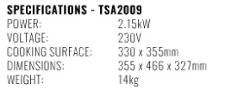 |  | R
ANVIL 600 Ribbed Griller Table Top or equally approved  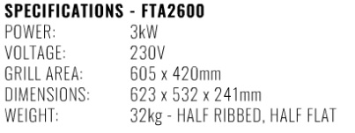 | 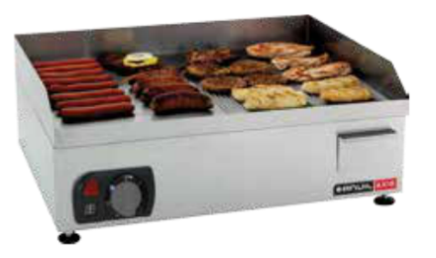 | R
ANVIL Chip Dump or equally approved   | 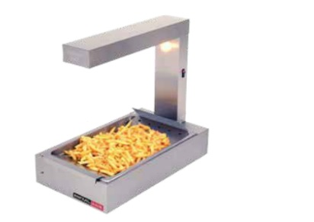 | R
ANVIL Single Chip Fryer or equally approved  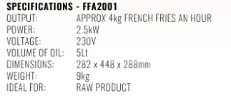 |  | R
Double Door Beverage Cooler Upright 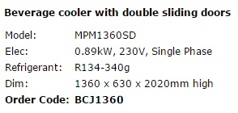 | 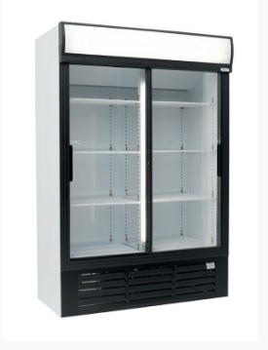 | R
Sharp R959SLMA 40 litre combination microwave or equally approved  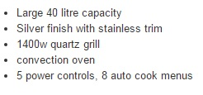 |  | R
SERVERY |  | R
COMERSA Cold well with Curved Glass Sneeze Guard or equally approved  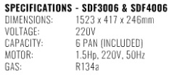 |  | R
SALVADORE 3 Division Bain Marie with Hot Closet & Curved Glass or equally approved. Bain Marie to be included.  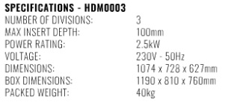 | 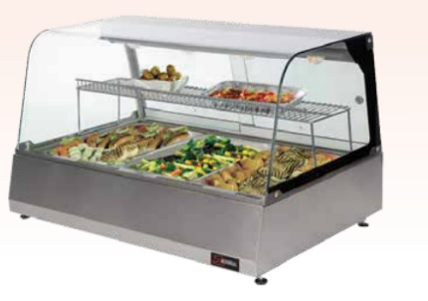 | R
Global Shelving or equally approved  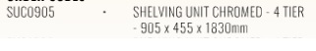 | 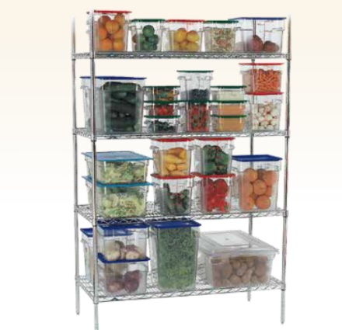 | R
Double Door Beverage Cooler Upright |  | R
Serving counter  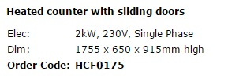 | 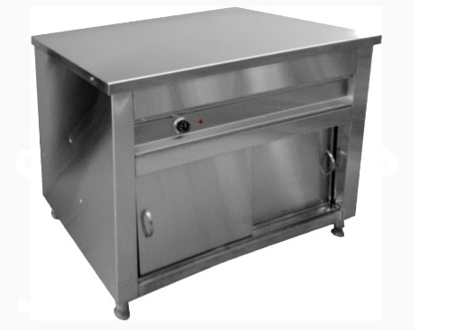 | R
Salad well  Stainless steel Salad Bar Cooler VRX1500/380 LID With Capacity 44L For Hotel: |  | R
  MODEL NO. | VRX1500/380 | Material | 201#/304#
  Product Name | Salad Bar Cooler | Application | Restaurant,Hotel,Cafe
  SIZE | 1500X380X430mm | Packing Size | 1550x450x290mm
  Temperature | +2℃~+8℃ | Defrost Type | Artifical defrost
  Refrigerant | R134a | Capacity | 44L
  Cooling Type | Static | Style | Single-temperature
  Warranty | 2 years
  Voltage | 220-240V/50Hz,230V/60Hz,110-115V/60Hz
  Temperature Control | Dixell or Carel
  Compressor | Embraco
  Container Qty | 20ft: 102pcs 40ft:222pcs
UMMIT Juicer or equally approved  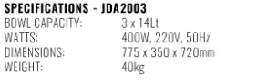 |  | R
MAIN COOKING AREA |  | R
ANVIL 900 Flat Top Gas Griller & Stand or equally approved  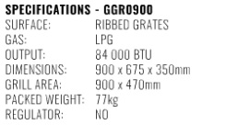 | 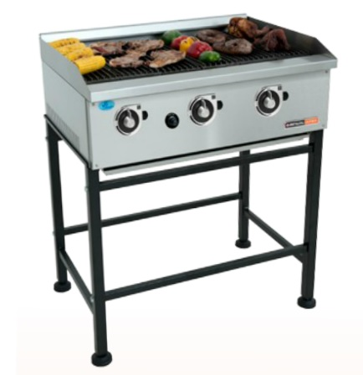 | R
Gas braai  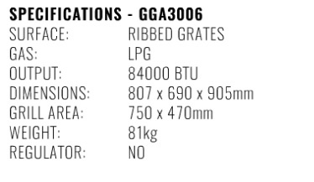 | 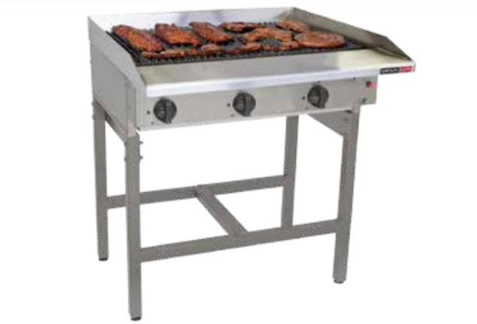 | R
ANVIL Gas stove with Electric oven or equally approved  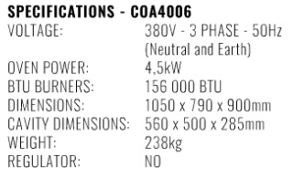 | 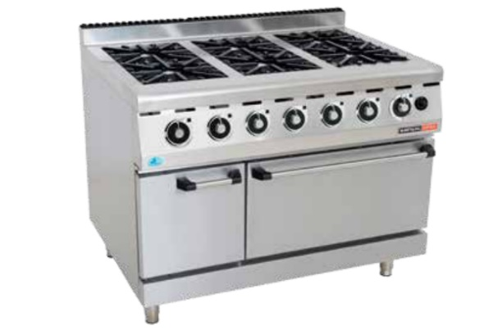 | R
PIRON 10 Pan Combi Steamer with Stand & Trays or equally approved  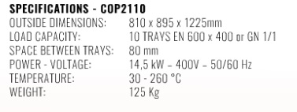 |  | R
Franke S/Steel hand wash basins size 420x340x185mm or equally approved |  | R
GLOBAL Chromed Shelving or equally approved   |  | R
Extraction Allowance (extractor fan). Extractor to be supplied and installed by specialist |  | R 50 000.00

PREPARATION |  | R
Table with Single Bowl & Over Head Shelf Centre :  Single bowl catering sink (FR-S1-1200L) with slatted under shelf (FR-US1200-SLA), standard deck mounted kitchen sink mixer (TE-MY1) | 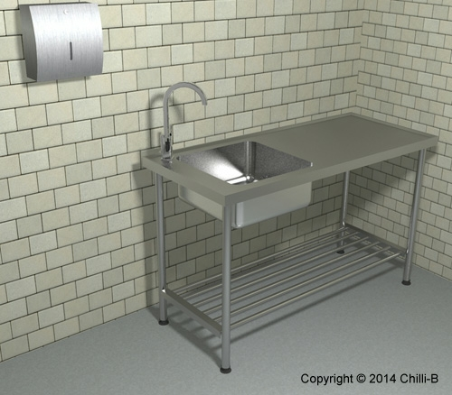 | R
3 door refrigerated catering prep fridge chiller counter solid top | 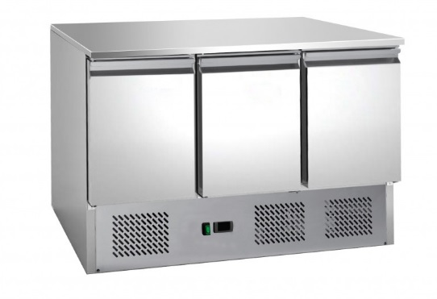 | R
Platform Scale 150kg  - Stainless steel platter & column  - Large LCD with white back-light display  - 220VAC & built-in re-chargeable battery – Up to 70 hours battery operation  - Overload protection  - Functions: Tare, Zero, Hold, Print, etc  - Auto zero tracking, auto & manual tare Audible alarm for pre-set weights  - Clock and Units conversion  - Weighing, counting, check-weighing Accumulating, animal weighing  - 60 000 Internal divisions  - RS232 output |  | R
Vegetable cutter  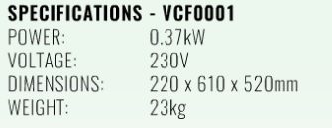 | 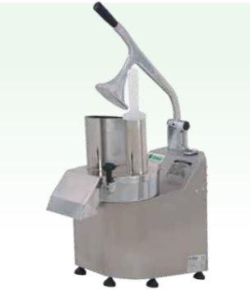 | R
Hydro boil  ZIP HydroBoil 10 litre Stainless Steel instant boiling water unit. Outer case manufactured from Stainless Steel with a two-way tap, complete with twin-chamber technology. Unit to be installed in accordance with manufacturer's installation instruction manual and (optional) equipped with Zip GlobalPlus Water Filtration Kit or equally approved. | 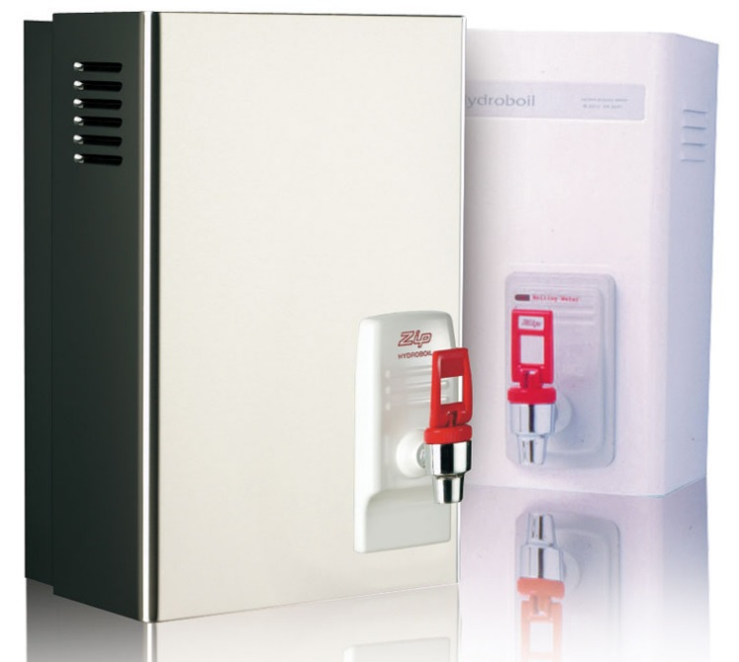 | R
WASH-UP |  | R
Dish Wash Table Inlet with Dump Hole & Pre-Rinse  Dishwasher inlet table with pre rinse bowl  • Fitted with high Splashback with boxed edges  • Sink size 450 x 450 x 250mm deep  • Fitted with one set of legs made from 304 grade stainless steel with 2 plastic adjustable foot pieces  • All sink tops manufactured from 430 grade stainless stee | 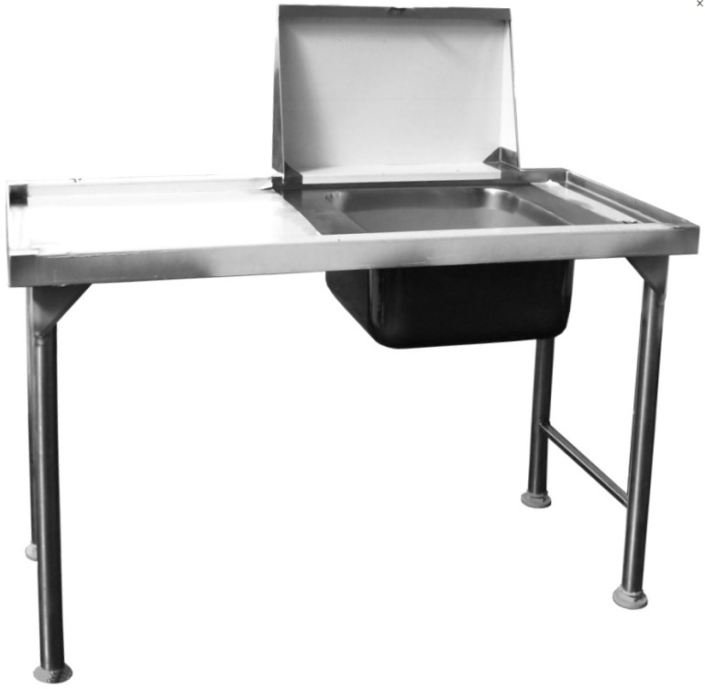 | R
  Dim: | 1100 x 600 x 915 mm high
  Order Code: | DIT0110
Sink. Dish Rack Angle Shelf | 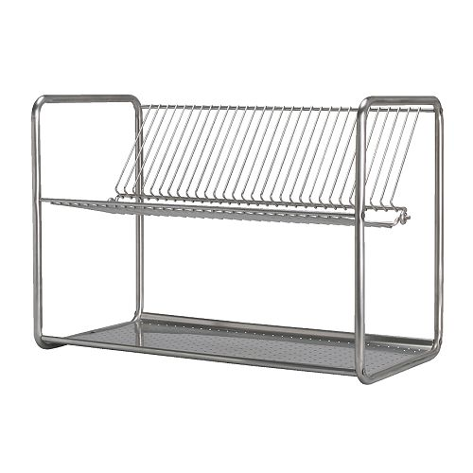 | R
DIHR Under counter Dishwasher or equally approved  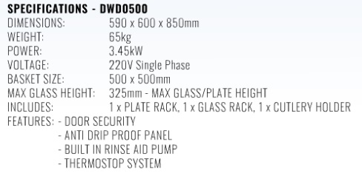 |  | R
MAC BROTHERS or equally approved Dish Wash Out-Let Table with Dish Rack - Angle Shelf  - Top from 1.2mm grade 430 Stainless steel with galvanised backing.  - Standard to hook onto hood type dishwasher with 1 set of legs from 40mmgrade 430 Stainless steel suare tubing.  - Top has a 50mm wide x 40mm high boxed edge to guide  - standard dish washing baskets.  - Curved roller outlet table for 90° corner available.  - Dishwasher basket rack to take 3 baskets. | 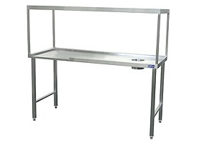 | R
Vulcan Single Bowl Pot Sink or equally approved with Pot Shelf 2.3m  Code: 3044419  - All 430 type stainless steel  - Pressed bowl AISI 304CR NI grade stainless steel with 40mm waste outlet  - 150mm high splash back to rear  - Stainless steel legs with adjustable foot pieces  - Heavy duty backing sheet with bitumastic sound deadening  - Dimensions: 900 × 650 × 910mm (H)  Pot Rack:  Free standing 4 tier pot rack 35 kg/m 1200 x 600 x 1450H  - Wall mounted racks from 25mm square tubing in grade304 Stainless steel.  - Legs from 40mm square grade 304 Stainless Steel tubing.  - Freestanding rack from 25mm square tubing supported on diameter 45mm round tubing legs, all from grade 304 Stainless steel. | 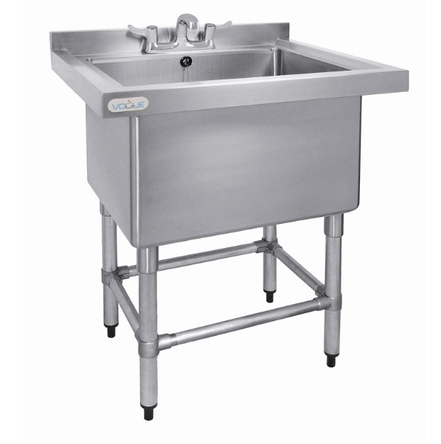  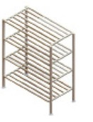 | R
Store Room |  | R
GLOBAL Chromed Shelving or equally approved |  | R
Global Shelving or equally approved |  | R
Global Crockery storage rack  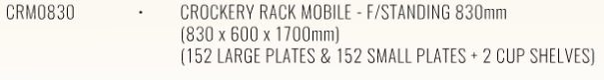 | 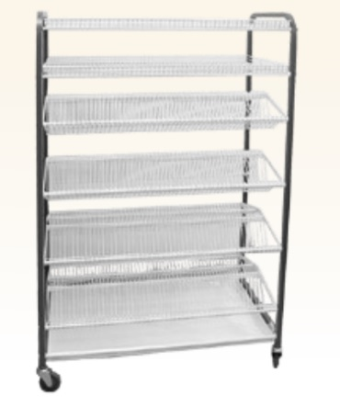 | R
Cold and Freezer Room |  | R
Cold and freezer room allowance including shelving  Size: 1200mm x 2400mm | 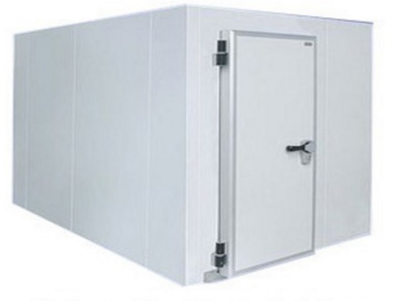 | R
Shop fitting |  | R
Serving Stations allowance 40cm |  | R
Smalls |  | R
Smalls Allowance |  | R
Global Refuse bins with lids or similar approved  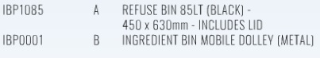 | 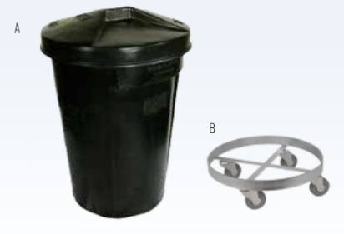 | R
Electronic Menu Boards  Size: 6 x 32Inch electronic display  Six(6) wall mounting allowance. |  | R
BUILDING |  | R
Commissioning / building /electrical and making good  allowance |  | R
Counter Tops and Cabinets SEE Attached Drawings |  | R
TOTAL VAT INCLUSIVE |  | R

Item No. | Evaluation Criteria Item :  90/10 Principle | Weight
 | Administrative Requirements
 | Price | 90
 | B-BBEE Status | 10
A | ADMINISTRATIVE REQUIREMENTS
Administrative requirements
The SBD (SBD1, SBD3.1, SBD4, SBD6.1 SBD8 and SBD 9)
A valid TAX Clearance Certificate Or TAX compliance status certificate/ SARS PIN ISSUED Certificate
Technical proposal.
B | FUNCTIONALITY
 | Demonstrate Experience in, supply and installation of canteen equipment or similar projects in the past five (5) years. At least three reference letters from current clients / Previous clients and contact details | 35
 | The bidder must provide brief description of the technical approach in installation and supply of canteen equipment | 35
 | The bidder must provide maintenance schedule per annum for the canteen equipment. | 30
 | NB: Minimum 60% qualifications on functionality.
 | GRAND TOTAL | 100

