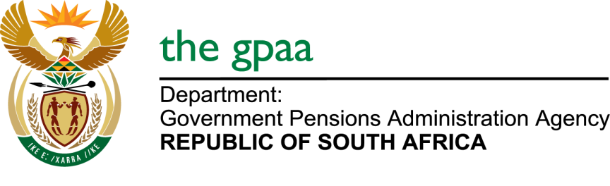

CLOSING DATE: 09 JANUARY 2017
SUPPLY AND DELIVERY OF CORPORATE UNIFORM BID GPAA 49/2016
NAME OF BIDDERS

1. Crystal Dawn Trading 30
2. Kgomhove Trading & projects
3. Naits Trading & Projects T/A Chezfaz Gifting & Apparel
4. Kgoga Masigo enterprise & projects
5. Selaki Sports & Leisure
6. Tau Ya Phoka
7. SSRN Ebony (Pty) LTD
8. Imvelo Centrics (Pty) LTD
9. Sengwayo Holdings CC
10. Image Corporate Wear
11. Ngcebo Investment

