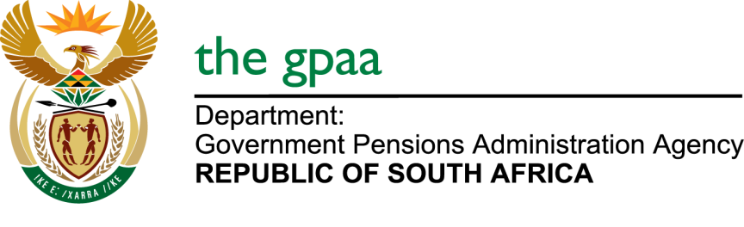

CLOSING DATE: 10 FEBRUARY 2017
EVALUATION OF THE EFFICIENCY AND EFFECTIVENESS OF BENEFIT PAYMENT PRODUCTIVITY BID GPAA 03/2017
NAME OF BIDDERS
- NMG Benefits
- S24 Business Group (Pty) Ltd
- FEM Research

